LAB 3

Sorting techniques

1. Sort a given set of N integer elements using Merge Sort technique and compute its time taken.

#include<stdio.h>

#include<time.h>

int a[20],n;

void simple_sort(int [],int,int,int);

void merge_sort(int[],int,int);

int main()

{

int i;

clock_t start, end;

double time_taken;

printf("Enter the no. of elements:");

scanf("%d", &n);

printf("Enter the array elements:");

for (i = 0; i < n; i++)

{

scanf("%d", &a[i]);

}

start = clock();

merge_sort(a, 0, n - 1);

end = clock();

time_taken = (double)(end - start) / CLOCKS_PER_SEC;

printf("Sorted array:");

for (i = 0; i < n; i++)

{

printf("%d ", a[i]);

}

printf("\n");

printf("Time taken to sort: %f seconds\n", time_taken);

return 0;

}

void merge_sort(int a[],int low, int high)

{

if(low<high)

{

int mid=(low+high)/2;

merge_sort(a,low,mid);

merge_sort(a,mid+1,high);

simple_sort(a,low,mid,high);

}

}

void simple_sort(int a[],int low, int mid, int high)

{

int i=low,j=mid+1,k=low;

int c[n];

while(i<=mid && j<=high)

{

if(a[i]<a[j])

{

c[k++]=a[i];

i++;

}

else

{

c[k++]=a[j];

j++;

}

}

while(i<=mid)

{

c[k++]=a[i];

i++;

}

while(j<=high)

{

c[k++]=a[j];

j++;

}

for(i=low;i<=high;i++)

{

a[i]=c[i];

}

}

**OUTPUT-**

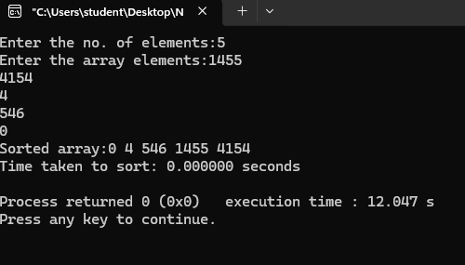

2.Sort a given set of N integer elements using Quick Sort technique and compute its time taken.

#include <stdio.h>

#include<time.h>

int a[20],n;

int partition(int [],int, int);

void quick_sort(int [],int,int);

void swap(int*,int*);

int main()

{

int i;

clock_t start, end;

double time_taken;

printf("Enter the no. of elements:");

scanf("%d", &n);

printf("Enter the array elements:");

for (i = 0; i < n; i++)

{

scanf("%d", &a[i]);

}

start = clock();

quick_sort(a, 0, n - 1);

end = clock();

time_taken = (double)(end - start) / CLOCKS_PER_SEC;

printf("Sorted array:");

for (i = 0; i < n; i++)

{

printf("%d ", a[i]);

}

printf("\n");

printf("Time taken to sort: %f seconds\n", time_taken);

return 0;

}

void swap(int *a,int *b)

{

int temp=*a;

*a=*b;

*b=temp;

}

void quick_sort(int a[],int low,int high)

{

if(low<high)

{

int mid=partition(a,low,high);

quick_sort(a,low,mid-1);

quick_sort(a,mid+1,high);

}

}

int partition(int a[],int low,int high)

{

int pivot=a[low];

int i=low;

int j=high+1;

while(i<=j){

do

{

i=i+1;

}

while(a[i]<pivot && i<=high);

do

{

j=j-1;

}

while(a[j]>pivot && j>=low);

if(i<j)

{

swap(&a[i],&a[j]);

}

}

swap(&a[j],&a[low]);

return j;

}

**OUTPUT-**

